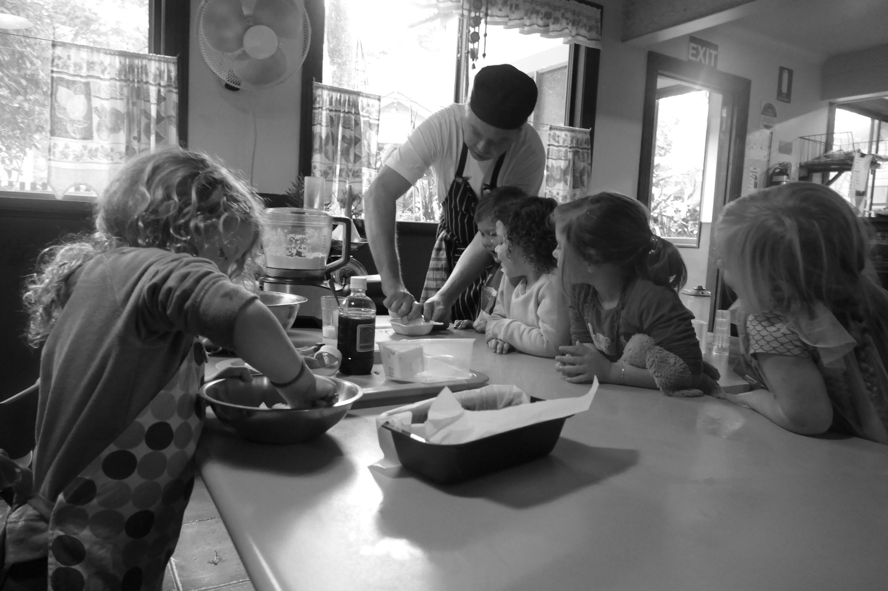
Milford Lodge

Term 3 News, 2018

Dear Milford Lodge Families & Friends,
The new CCSS is up and running, with not too many hiccups. The world did not end, and thankfully, the children have remained oblivious to the changes by the government and the mass hysteria that ensues. In fact, they have continued to do what they do best – play!
Very much behind the scenes, but we must acknowledge the hard work of our awesome software provider, David, from Heartbeat4kidz. We have heard some horror stories and seen much of the mass hysteria leaked out through social media pages, with directors and administration folk alike, banging their heads against their desks due to the technical issues they are experiencing. Our transition has been fairly smooth, and we believe he has gone above and beyond to ensure that his clients have had less work to do during this time. Thanks David!
In other news, we have many exciting things to share from this past 3 months, as well as exciting news ahead.
Enjoy!
Team Milford x
GEVER TULLEY IS COMING!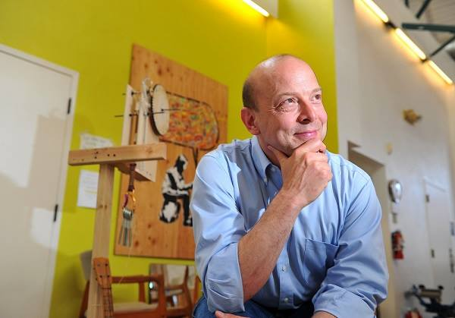
After three years of stalking this inspiring man – we finally have him on a plane – direct to us. We would like to thank our friends at Real World Learning (Niki & Bron) for offering to arrange his tour and bookings.
Gever Tulley started the Tinkering School, followed by SF Brightworks, and is the co-author of “50 Dangerous Things (You should let your children do)”.
He has never been to Australia, and is very excited to be bringing along his colleague Mackenzie-Rose Price, a founding member of the Teaching Team at SF Brightworks.
Whilst the original brief was keynote & workshop at our annual Village Ways conference, we been granted a few additions to our booking.
We are very pleased to announce that we will be offering an evening for our families with Gever Tulley (at no cost to you!)
Date: Thursday 26th July
Time: 5.30pm – 7.30pm
Light refreshments will be served
We would ask that families please RSVP this event ASAP.
We have also offered a session with Gever Tulley, which Woombye State School have kindly accepted to host, on Monday 31st July from 4.00pm.
This will be open to the community.
Not sold? Feel free to watch one of his many TED Talks / other videos. This is one of our favourites: https://www.youtube.com/watch?v=oyWA3p4aVHM
…Team News…
Thank you to all of the wonderful feedback that our families have shared with us regarding Thomas. He is very much enjoying being a part of Milford Lodge, sharing with us that he has never realised how amazing Early Childhood could be.
He also said that his first staff catch up was the best and most fun ‘meeting he’d ever been to.’ We have loved watching his energy and his interactions with the children.
~
Many Friday families may now know Ellandi. Ellandi finished at Milford Lodge in 2012.
Ellandi has been volunteering after school on a Friday, and sometimes in the holidays.
At only 10 years of age, she brings so much into our place – hopefully she continues to volunteer until an age that she is able to complete a traineeship!
~
Pippa has completed some year 10 work experience with us these holidays and is very excited to be given the opportunity to start a school based traineeship this term.
She impressed the Avocado Cottage Team during her time here, and we are sure she will enjoy her traineeship at Milford Lodge.
~
Sadly Tegan will no longer be offering her ballroom sessions on a regular basis as she focuses on her own business and her family. We would like to thank Tegan for the magic she created in one of our most treasured spaces. She will be missed greatly! Though, we may still see her from time to time
~
Whilst it is not fully official, we would like to congratulate Izzy on the completion of her Diploma. Izzy was our first School Based Trainee, working primarily in the Kindergarten room. I recall the fun and joy from my own daughter, Niamh, on the days when Izzy was in the room. Fast forward to now, and we have up to 6 School Based Trainees at any time. Thank you for asking us Izzy! And congratulations!
Professional Development
APRIL ~ MAY ~ JUNE
- KU Inclusion Support – Brain Development Forum
- KU Inclusion Support…
- Hearts & Minds….
- Justine Urbahn
- Office or Early Childhood Network Meeting – Exceeding Standards (changes)
JULY ~ AUGUST ~ SEPTEMBER
- VILLAGE WAYS!!!! (Gever Tulley, Mackenzie-Rose Price, Sally Lawrence, and more)
- Nature Nurture (UK)
- Australian Learning Tracks with Niki Buchan
- Niki?
- Other?
BUDERIM GARDEN FESTIVAL
Milford Lodge has been approached to be a part of the annual Buderim Garden Festival this year.
October is already our busiest month, and we have so many projects commenced, however we love a good challenge!
Each participant receives a $300 donation. Seeing as Milford Lodge does not accept donations, we have offered to use the $300 to create a small world gardening exhibit in which our children and the community can enjoy.
We have promotional flyers in our foyer and hope that some of our families can attend this event. Our friends over at Art Nuvo are also being asked to participate this year, so ours will be a busier stopover.
Thank you to the Buderim Garden Club for kindly inviting us to join in this wonderful opportunity to share our home with the community

www.buderimgardenclub.com
Mindfulness at Milford
Written by Emily Spurling
You may have heard the buzz word Mindfulness but what is it really and how can it help us and our children? Have you ever said or done something and wished you could take it back? Mindfulness teaches us to be extremely present in the moment which creates the space for us to respond rather than react. Have you ever had negative thoughts you wish weren't there? Mindfulness allows us to step back and observe our mind and our emotions without being caught up and carried away in the 'story'. In an environment like Milford mindfulness can create a more harmonious playground and classroom by teaching children how to regulate their emotions and be able to focus on tasks for longer. Research has found children who learn mindfulness are more compassionate, better behaved and less anxious. To learn more about the Mindfulness program and how you can integrate it into your home please see the Parent Mindfulness Manual. If you wish to read more about the Mindful Schools Program or get it to run at your school, go to:
http://emilyspurling.com/?page_id=287​

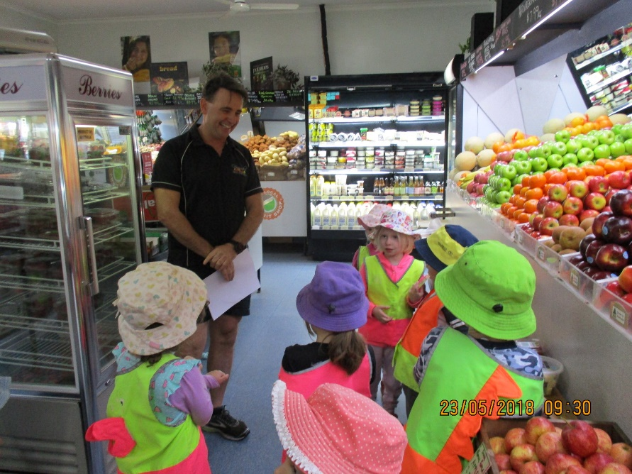
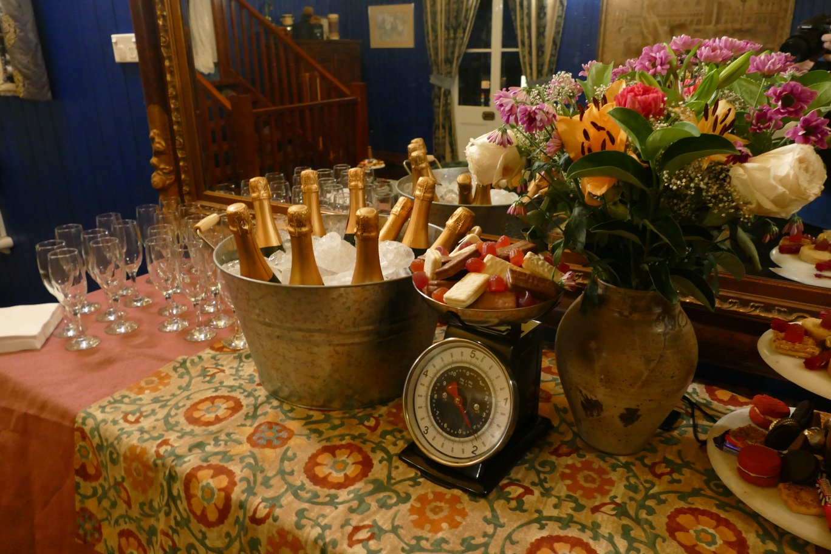
What’s cooking?
Over the past few months the children have been

New Regular Outings
What an exciting time it has been boarding the Sunshine Coast Mobile (Truck) Library. What’s not to love?! It’s a library…. On a TRUCK!
Alongside this, the children have been visiting Fenwick’s Fruit Emporium to select and purchase their own fruit for afternoon tea each time.
Alan Fenwick greeted the children on their very first visit, and took the time to show them his family shop.
Milford Mummies’ Night Off
Thank you to all of the lovely ladies who came along to share in our night off.
We all had a beautiful evening, filled with lots of laughs, wonderful stories and even some joyful tears.
We hope to see you all again next year.

